**MIDDLE EAST TECHNICAL UNIVERSITY**

ELECTRICAL & ELECTRONICS ENGINEERING

*EE464 – STATIC POWER CONVERSION 2*

*TERM PROJECT – SIMULATION REPORT*

Ahmetcan Akuz 2025468

Atilla Can Aydemir 2374510

Barış Özgören 2375558

Table of Contents

Introduction…………………………………………………………………………………………………………………………………3

1. Topology Discussion………………………………………………………………………………………………………………………4
2. Magnetic Design………………………………………………………………………………………………………………..…………..6
   1. Power Calculations……………………………………………………………………………………………………….…6
   2. Core Selection…………………………………………………………………………………………………………………6
   3. Transformer Characteristics and Calculations………………………………………………….………………7
   4. Cable Selection……………………………………………………………………………………………..……………..…8
   5. Core and Copper Loss……………………………………………………………………………………………………..8
3. Design Decisions……………………………………………………………………………………………………………10
4. Simulation Results…………………………………………………………………………………………………………13
5. Component Selection……………………………………………………………………………………………………17
6. Further Discussion………………………………………………………………………………………………………..18
7. Conclusion…………………………………………………………………………………………………………………….18

References. ………………………………………………………………………………………………………..…………18

Introduction

The main purpose of this project is converting 12-18VDC range input voltage to 48VDC output by using isolated converter. The power requirement for this design is 48W at output. This design must be regulated, and line and load regulation should not decrease below 3%. With respect to these parameters, different isolated converted topologies are compared, and the selection of optimum converter design is explained in detail. The transformer for this topology is design and explained design steps. Moreover, the simulation of the design is investigated and compared with analytical results. This simulation is made by the components that are chosen by looking rated current and voltage levels. Whole graphs for switch, primary and secondary side voltage and currents. The snubber design for this topology is explained in detail. Finally, the loss calculations are done for MOSFET, diode and transformer of the design.

1. Topology Discussion

In this project, an isolated DC-DC converter will be designed with the specifications as can be seen from Table 1.

|  |  |
| --- | --- |
| Vin,min | 12V |
| Vin,max | 18V |
| Vout | 48V |
| Pout | 48W |
| Vout,pp Ripple | 3% |
| Line Regulation | 3% |
| Load Regulation | 3% |

Table 1. Specifications of the Project

There are 5 candidates for this isolated DC-DC converter which are as follows:

* Flyback Converter
* Forward Converter
* Push-Pull Converter
* Half-Bridge Converter
* Full-Bridge Converter

The final decision on the topology used on this project is decided by discussing the advantages and disadvantages of each of these topologies. After careful examination, using the flyback converter topology is decided. Flyback is the easiest to control and the smallest sized converter in these five topologies. Less number of switches in the flyback converter also means smaller switching losses, which was another factor in selecting this selection process. Although there are certain advantages of other topologies, the control of switches is deemed problematic as turning on both switches at the same time for push-pull, half-bridge and full-bridge converters may blow up the converter. On the other hand, the forward converter is avoided mainly because of the limitation it brings to the maximum duty cycle.

|  |  |  |
| --- | --- | --- |
| Topology Name | Advantages | Disadvantages |
| Flyback Converter | * Only one switch is needed, so it is easier to control. * Comparatively smaller in size because no additional inductor is used. * Only one switch, so smaller switching losses. | * The peak current and voltage through the switch are high. * High output current ripple. |
| Forward Converter | * Power is transferred immediately. * Low output current ripple. * If a third winding topology is used, the energy is transferred back to the supply. * Only one switch, so smaller switching losses. | * RCD snubber circuit or a third winding on the transformer is necessary. This causes heat or worse fill factor. * One inductor is used, slightly bigger size. * Maximum duty cycle is limited to $\frac{1}{(1+\frac{N_{3}}{N1})}$, otherwise core will saturate. |
| Push-Pull Converter | * Better use of core, 2 quadrant operation (1st and 3rd Quadrants). | * Two switches need to work together, hard to control. * Center tapped transformer will mean worse fill factor in the transformer. * One inductor, two diodes, two switches cause bigger size and switching losses. |
| Half-Bridge Converter | * Small output current ripple. | * One inductor, two diodes, two switches cause bigger size. * Small variances in the capacitances in the primary may cause unbalanced voltage division among them. |
| Full-Bridge Converter | * Small output current ripple. * Higher gain with the same turns ratio and duty cycle. | * 4 switches working synchronously, worse switching losses. |

Table 2. Advantages and disadvantages of each topology

The specifications in Table 1 suggests that the converter will need to take input between 12V and 18V. Considering the gain formula for the flyback converter is $\frac{V_{O}}{V_{in}}=\frac{D}{1-D}*\left(\frac{N_{2}}{N1}\right)$, the maximum duty cycle is selected as 0.5 and turns ratio N1:N2 is selected as 1:4. This selection is valid when the input is 12V. When the input is 18V, the duty cycle becomes 0.4 and this is the minimum value. Hence, the converter should be able to operate at a duty cycle range of 0.4 to 0.5.

In order to work this converter at the DCM CCM border region, the following calculations can be completed. Ripple current of LM is equal to the max current of LM, because in the border region, the minimum current value is equal to zero.

$$V_{S}*D*\frac{T_{S}}{Lm}=ΔI_{Lm}=7.51A=I_{Lm,max}$$

$$P_{source}=0.5*I_{Lm,max}*0.5*12=22.53W=I_{out}*V_{out}$$

$$I_{out}=0.47A$$

1. **Magnetic Design**
   1. Power Calculations

The design of the transformer is one of the most critical parts of flyback topology. The maximum duty cycle for this design is 0.5 and the flyback operates at CCM. To design transformer and choose core, the worst-case Lm can be calculated from the Equation M1 firstly [M1].

$L_{m}=\frac{(V_{min}D_{max})}{2P_{in}f_{s}K_{RF} }$ (M1)

In the equation, Vmin is given as 12V and Dmax is specified before as 0.5. The desired efficiency is 85%. Therefore, from output power requirements, input power can be found as around 56.5W. The Lm can be found as 13.3uH from equation M1. In the next step to find turns ratio, peak and rms current value of primary side must be found. The peak current and rms can be found from the equation M2 and M3 respectively.

$I_{p}=\frac{2P_{in_{max}}}{V_{min}D_{max}}$ (M2) ${I_{p}}_{rms}=I_{P}\sqrt{\frac{D_{max}}{3}}$ 
 (M3)

From equation M2 and M3 peak and rms current can be found as 18.8A and 7.68A respectively. After these parameters are calculated, the saturation of flux density must be specified. Since there is no limitation for this design, Bmax can be selected as 0.3T. With these parameters the core for transformer was selected.

* 1. Core Selection

There are two important parts of core selection. One of them is core type and another one is dimensions and magnetic parameters of the core. In this design, two types of cores were considered because of other cores’ prices. These are powdered core and ferrite core. Even if powdered core store more energy than ferrite core, the ferrite core has higher magnetic permeability for high frequencies. Since the switching frequency of the design is 60kHz, ferrite will be a more reasonable option. This low permeability can cause more leakage inductance for powdered core. Because of these reasons, ferrite core was chosen as core type.

Two ferrite core option was simulated with all calculations. These are 00K3515E090 and E42/21/20-3C94. The effective area of 00K3515E090 is much smaller than E42/21/20-3C94. This is good for core loss and compactness. However, this cause more turns for winding and the transformer will be handmade to change easily for alternative solutions. Therefore, choosing larger effective areas can provide easier production process for transformer. Therefore, E42/21/20-3C94 was selected as core of the flyback transformer. The dimensions and mechanical drawing of the core can be seen in Figure 1.

Figure 1 Dimensions and Parameters of E42/21/20

* 1. Transformer Characteristics and Calculations

Once the core has been determined, the first step will be to decide on the turns ratio of transformer. To decide on this, equation M4 can be used.

$n=\frac{Vin_{min}D_{max}}{(Vout+V_{D})(1-D_{max})}$ (M4)

From M4, turns ratio was found as 0.244. Then the turns number in primary side was found from Equation M5. It is 3.57. Since selecting it as an integer will make easier handmade production, it was rounded to4. Therefore, the turns number of secondary side is 16.

$N_{p}=\frac{L_{m}I_{p}}{B_{sat}A_{e}}x{10}^{6}$ (M5)

Before cable selection, rms and peak current of the secondary side should be chosen. These can be chosen according to M6 and M7 respectively. From these equations peak and rms current was found as 4.70 A and 1.92 Arms.

(M6)

(M7)

* 1. Cable Selection

To make correct cable selection, firstly area of cable should be determined. To find this areas, current density should be selected. For long cables, current density can be taken as J=5A/mm^2. From this value, copper area primary and secondary current can be calculated with respect to M8.

$A_{copper}=\frac{I_{rms}}{J}$ (M8)

The copper areas of primary and secondary side can be found as 1.53mm^2 and 0.38mm^2 respectively. To choose appropriate cables for the design, American Wire Gauge Table should be checked. From the Table-1, AWG15 cable for primary and AWG 21 can be chosen for secondary side winding. However, the skin depth of the cables should be considered. According to this table, AWG 15 reaches its skin depth limit at 8250 Hz and AWG-21 reaches it at 33 kHz. However, system switching frequency is 60 kHz. So, smaller but parallel cables should be chosen. The AWG-24 is suitable for this design because it reaches its limit at 68 kHz. Finally, AWG-24 was chosen, and it will be paralleled 8 times at primary and 2 times at secondary.

|  |  |  |  |  |  |  |  |  |  |
| --- | --- | --- | --- | --- | --- | --- | --- | --- | --- |
| G gauge | Conductor | Conductor | Conductor cross section in mm2 | Ohms per 1000 ft. | Ohms per km | Maximum amps for chassis wiring | Maximum amps for | Maximum frequency for | Breaking force Soft Annealed Cu 37000 PSI |
| Diameter Inches | Diameter mm | power transmission | 100% skin depth for solid conductor copper |
| **15** | 0.0571 | **1.45034** | **1.65** | 3.184 | 10.44352 | 28 | 4.7 | 8250 Hz | 94 lbs |
| **16** | 0.0508 | **1.29032** | **1.31** | 4.016 | 13.17248 | 22 | 3.7 | 11 k Hz | 75 lbs |
| **17** | 0.0453 | **1.15062** | **1.04** | 5.064 | 16.60992 | 19 | 2.9 | 13 k Hz | 59 lbs |
| **18** | 0.0403 | **1.02362** | **0.823** | 6.385 | 20.9428 | 16 | 2.3 | 17 kHz | 47 lbs |
| **19** | 0.0359 | **0.91186** | **0.653** | 8.051 | 26.40728 | 14 | 1.8 | 21 kHz | 37 lbs |
| **20** | 0.032 | **0.8128** | **0.519** | 10.15 | 33.292 | 11 | 1.5 | 27 kHz | 29 lbs |
| **21** | 0.0285 | **0.7239** | **0.412** | 12.8 | 41.984 | 9 | 1.2 | 33 kHz | 23 lbs |
| **22** | 0.0253 | **0.64516** | **0.327** | 16.14 | 52.9392 | 7 | 0.92 | 42 kHz | 18 lbs |
| **23** | 0.0226 | **0.57404** | **0.259** | 20.36 | 66.7808 | 4.7 | 0.729 | 53 kHz | 14.5 lbs |
| **24** | 0.0201 | **0.51054** | **0.205** | 25.67 | 84.1976 | 3.5 | 0.577 | 68 kHz | 11.5 lbs |
| **25** | 0.0179 | **0.45466** | **0.162** | 32.37 | 106.1736 | 2.7 | 0.457 | 85 kHz | 9 lbs |
| **26** | 0.0159 | **0.40386** | **0.128** | 40.81 | 133.8568 | 2.2 | 0.361 | 107 kHz | 7.2 lbs |

Table *3*- American Wire Gauge (AWG) Conductor Table

* 1. Core and Copper Loss

To design transformer of flyback, all parameters is considered. However, the performance of the transformer should be calculated to see efficiency of overall system. The core loss can be found by using Steinmetz’ Equation.

$P_{core}=af^{x}B^{y}V_{core}$ (M9)

The a, x and y values can be found at the core’s datasheet. Ferroxcube provides a excel sheet for these coefficients. From this sheet, a, x and y are 3.530102481, 1.419999968 and 2.884999936 respectively. The volume of the core can be calculated from dimensions of core and it is 5130mm^3. When these parameters are put to equation M9, core loss can be found as 2.52W.

$$P_{core}=\left(3.53\right){\left(60000\right)}^{1.42}{0.3}^{2.88}\left(5130*{10}^{3}\right)=2.52W$$

The other loss is copper loss of the transformer. To find cupper loss, resistivity of coppers should be found firstly. The resistivity can be found with respect to the equation M10.

$R=\frac{N*MLT}{(\# of parallel cables)}$ (M10)

From this equation, resistivity of primary and secondary side can be found as 2.47mΩ and 39.5mΩ respectively. The cupper loss can be calculated by using equation M11.

$P_{copper}=P_{cu,pri}+P_{cu,sec}$ (M11)

$$P_{cu}={\left(7.68Arms\right)}^{2}\left(2.47mΩ\right)+{\left(1.92Arms\right)}^{2}\left(39.5mΩ\right)=0.29W$$

Output Voltage Ripple Calculation for Worst Case (Minimum Input Voltage, Maximum Load)

$$∆V=48*0.03=1.44V ∆Q=C ∆V$$

$$\frac{I_{out} ∆t}{C}=\frac{I_{out} D T_{s}}{C}=∆V$$

$$C_{out}=\frac{1*0.5}{60*{10}^{3}*1.44}=5.78 μF$$

**Note:** To keep the voltage less reactive during sudden load changes, we will be using an output capacitor $C_{out}=47 uF$. Choosing these values ensures that we both satisfy the output voltage ripple constraint and regulation constraint.

RCD Snubber Calculation

Let $V_{snub}=2.5 V_{in}=30V$

$$I_{pri_max}=I_{pri_avg}+\frac{1}{2}I_{ripple}=\frac{\left(Vout+V_{f}\right)I_{out}}{V_{in} f_{s} D T_{s}}+\frac{V_{in} D T_{s}}{2 L_{pri}}=\frac{\left(48+0.7\right)*1}{12*60*{10}^{3}*0.5*\frac{1}{60*{10}^{3}}}+\frac{12*0.5}{2*13*{10}^{-6}*60*{10}^{3}}=12 A$$

Let ${ΔV}_{snub}=0.1 V_{snub}=3V$

$$ΔV_{snub}=\frac{V_{snub}}{C_{snub}*R_{snub}*f_{s}}$$

$$3=\frac{30}{C_{snub}*R_{snub}*60*{10}^{3}} => C_{snub}=\frac{30}{3*480*60*{10}^{3}}=347 nF$$

$$R_{sn}=\frac{V_{snub}^{2}}{\frac{1}{2}L_{leak}*i_{peak}^{2}*\frac{V_{snub}}{V_{snub}-V_{in}}*f_{s}}$$

$$R_{snub}=\frac{V_{snub}^{2}}{\frac{1}{2}13*{10}^{-6}*0.02*{12}^{2}*\frac{30}{30-12}*60*{10}^{3}}=480 Ω (Assumed leakage inductance is \%2)$$

RC Snubber Calculation

In calculating the RC snubber for the secondary side diode, procedure in [2] was followed.

Oscillation frequency: $f_{0}=10MGhz$

Shifted oscillation frequency $f_{1}=4MGhz$ with parallel capacitor $C_{1}=1000pF$

Snubber resistor $R_{snub}=83.56Ω$, snubber capacitor $C_{snub}=571.43pF$

**Note:** In order to optimize the losses and reduce the peak oscillation voltage and frequency to a desired value, the final values of the components were changed as follows:

$R_{snub}=100Ω$, $C_{snub}=330pF$

1. Design decisions

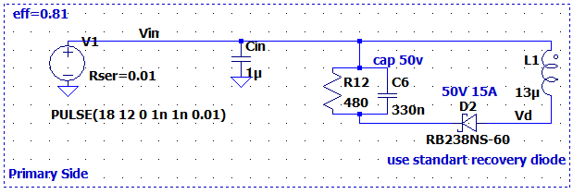

Figure 2 Primary Side of the Flyback Converter

-Since our power specification is 1W, it is reasonable to choose $C_{in}=1 μF$

-The RCD snubber components are chosen regarding the section before.

-The snubber diode is chosen so that it can supply the average snubber current and peak oscillation currents.

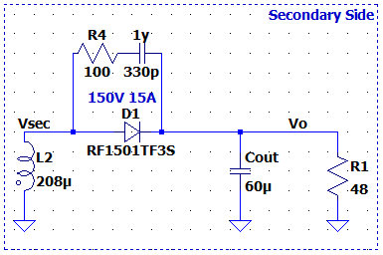

Figure 3 Secondary Side of the Flyback Converter

-Since there are no 60 uF capacitors available commercially, we opted to include an output capacitor .

- The RC snubber components are chosen regarding the section before.

-The output diode will be able to withstand peak currents of the oscillations and the average output current.

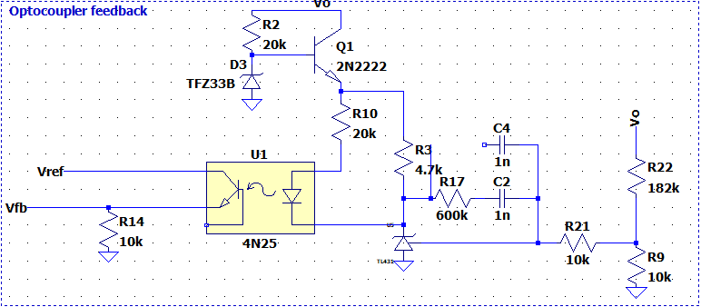

Figure 4 Optocoupler Feedback Configuration

-TL431 Adjustable Voltage Reference is used to provide feedback from the output voltage. Since it can achieve 2.5V at the reference pin, we can reflect that voltage to the output using a voltage divider network. Since the maximum operating voltage of TL431 is 37V, a linear regulator is implemented with a 30 Zener diode to protect the component. Because this stage is not a power stage, the power loss from the linear regulator is negligible.

-4N25 optocoupler is used because it is included in the LTSpice library. The resistors are connected to the optocoupler anode adjusts the controller parameters, so it is chosen such that is slows down the response. A 4.7k resistor is connected in order to protect the component.

-TL431 component is used as a PI controller in this stage. The parameters of the controller is adjusted so that the regulation constraints are satisfied. In this resistor and capacitor configuration, the converter satisfied these requirements. If required, a compensation capacitor can be adde to the controller to slow down the response.

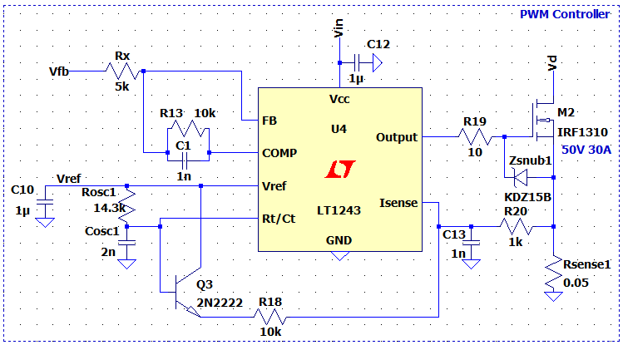

Figure 5 PWM Controller Configuration

-For our controller IC, we opted to use UC 3843 Current Mode PWM Controller(LT1243 is pin to pin equivalent of this IC in LTSpice) because of its current mode abilities. It includes a gate driver for the MOSFET and can operate up to %100 duty cycle (Although our maximum duty cycle is %50).

-Since we are operating at 60kHz frequency, our $R_{osc} and C_{osc}$ values were chosen accordingly to set the oscillator frequency inside the PWM controller.

-A protection Zener diode is used to protect the MOSFET $V_{GS}$ from voltage spikes. Additionally, A 10R resistor is used to limit the charging currents of the MOSFET capacitors.

-1μF bypass capacitors are used to supply a reasonably constant input and reference voltage to and from the IC.

-To use the current mode capability of the IC, we will be using a 50mΩ sense resistor to measure the primary current. To supply a noise-free voltage $I_{sense}$ pin of the controller, a low-pass filter is implemented on the sensed voltage. Additionally, a slope compensation network is implemented to reduce the voltage spikes in the waveform.

-The controller parameters of the controller are determined by trial and error and the resistor and capacitor values are chosen to provide adequate Kp and Ki values.

1. Simulation Results

The simulations are conducted with $f_{s}=60kHz$, ${ V}_{in}=12V,$ $R_{load}=48Ω$



Figure 6 Waveforms for Vpri ,VDS ,Ipri respectively for ideal case



Figure 7 Waveforms for Vo, Vsec, Idiode respectively for ideal case



Figure 8 Waveforms for Ipri ,VDS, Vpri respectively for non-ideal case (No RCD snubber)



Figure 9 Waveforms for Vsec, Vo, Idiode respectively for non-ideal case (No RCD snubber)



Figure 10 Waveforms for I_pri,V_DS,V_pri respectively for non-ideal case (With RCD snubber)



Figure 11 Waveforms for Vsec, Idiode,Vo respectively for non-ideal case (With RCD snubber)

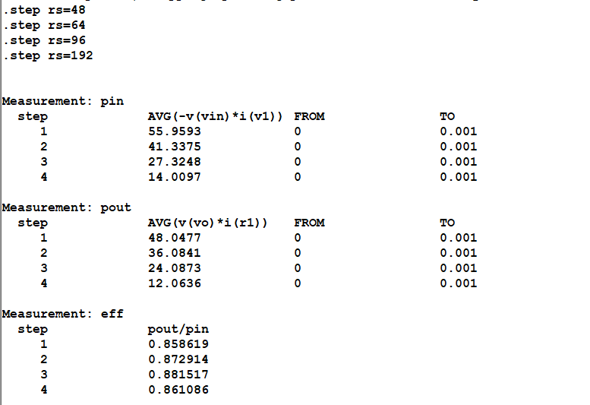

Figure 12 Efficiency at %100, %75, %50, %25 loads

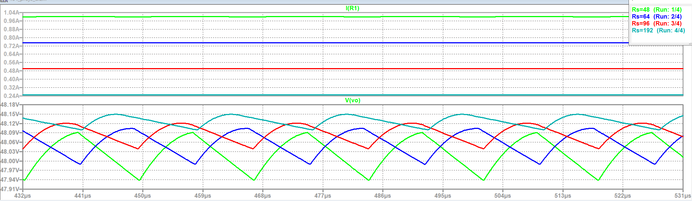

Figure 13 Output Voltage and Current waveforms at %100, %75, %50, %25 loads

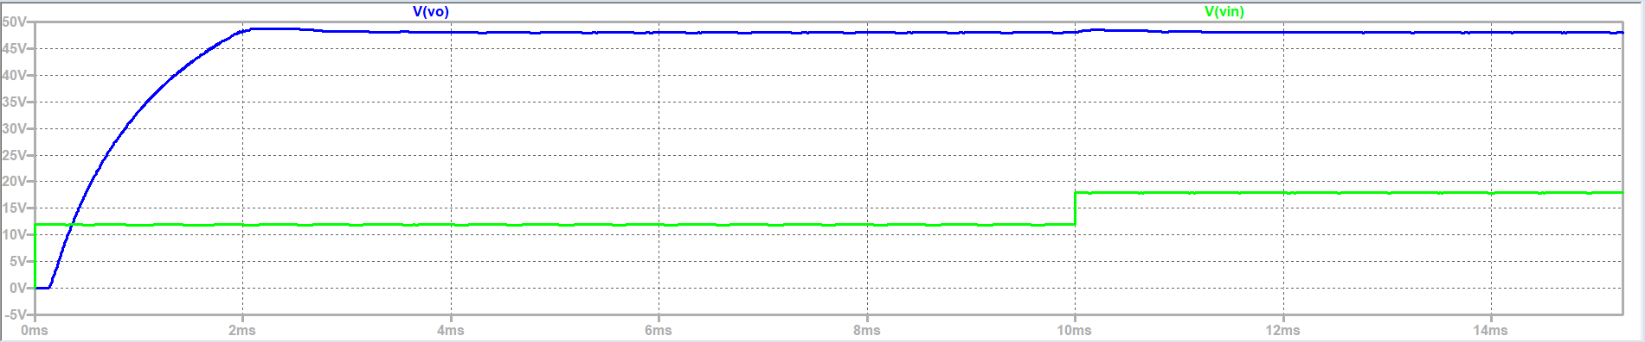

Figure 14 Output and Input Voltage waveforms for Low Input Voltage to High Input Voltage Situation



Figure 15 Output Voltage waveform for %100 Load to %10 Load Condition

1. Component Selection

In the flyback converter there are two critical component selections. These components are diode and switch (MOSFET). While choosing the components, we have decided to stay in the safe zone at first such that our converter would work as intended. After constructing the circuit, we are planning to change the components with narrower ratings to achieve a more efficient converter. While choosing the switch, there are two considerations which are the peak switch current and peak switch voltage.

$$V_{SW,peak}=\frac{V_{d}}{1-D}=\frac{18}{0.4}=45V$$

$$I_{SW,peak}=\frac{1}{(1-D)}*\frac{N1}{N2}*I_{O}+\frac{N1}{N2}*\frac{\left(1-D\right)}{2Lm*f_{s}}V_{O}= 5.01A$$

In the simulations, it is seen that Vds peak is around 60V, however we will be going for a safer option and use a 200V, 9A rated IRF630 MOSFET.

From the LtSpice simulations, it is also seen that a diode with about 150V and 15A ratings should be selected to achieve safe working conditions. We have decided to select MUR1615CT diode to meet our requirements. This diode has 150V and 16A ratings.

For the RCD snubber circuit, we have decided to use RB238NS-60 Schottky barrier diode, which has 60V and 40A ratings.

1. Further Discussion

For the magnetic design, different core alternatives will be tried. The effect of gapped and ungapped core will be compared and the optimum gap length will be chosen for the flyback topology. The thermal properties of the converters will be considered while constructing the converter.

1. Conclusion

In this project, we will design an isolated DC-DC converter with certain specs. In this simulation report, the decision process of the topology, the magnetic design parameters, design decisions and simulations are included. The efficiency of the converter under various load conditions is also included. We have chosen the flyback topology because of its smaller size, better switching losses because it contains only one switch and the freedom of choosing a duty cycle, which is not present in forward converter. The flyback converter is also easier to control, as it only needs one gate signal to control the only switch it has. Through the magnetic design process, we have gone through many iterations to reach the most ideal magnetic design parameters for the project. For future work, we will be ordering the components and completing their tests before constructing the system. In the simulations, we have reached the specifications for this design, and we will construct the converter accordingly.

References

1. “Application Note AN-4147 Design Guidelines for RCD Snubber of Flyback Converters,” 2006. [Online]. Available: https://e2e.ti.com/cfs-file/__key/communityserver-discussions-components-files/196/Design-Guidelines-for-RCD-Snubber-of-Flyback-Converters_2D00_Fairchild-AN4147.pdf. [Accessed: 05-May-2023].
2. J. Betten, “Power tips: Calculate an R-C snubber in seven steps,” *Power management - Technical articles - TI E2E support forums*, 05-May-2016. [Online]. Available: https://e2e.ti.com/blogs_/b/powerhouse/posts/calculate-an-r-c-snubber-in-seven-steps. [Accessed: 05-May-2023].
3. T. H. Chen, W. L. Lin and C. M. Liaw, "Dynamic modeling and controller design of flyback converter," in IEEE Transactions on Aerospace and Electronic Systems, vol. 35, no. 4, pp. 1230-1239, Oct. 1999, doi: 10.1109/7.805441.
4. R. Sheehan, “Understanding and applying current-mode control theory ,” 31-Oct-2007. [Online]. Available: https://www.ti.com/lit/an/snva555/snva555.pdf. [Accessed: 05-May-2023].